

Compare them with other peoples

It take lot of time to convey message

They try to do it in easy manner

Does they understood, I conveyed sign Language ?

Unable to talk with normal people in continuous flow

It is very difficult to convey message to You.

Empathy Map Canvas

Gain insight and understanding on solving customer problems.

1

Build empathy and keep your focus on the user by putting yourself in their shoes.



Whether other's can understand what I am saying

I can't Understand what they are trying to say

It is very difficult to make conversion to normal people

Does message conveyed correctly or not ?

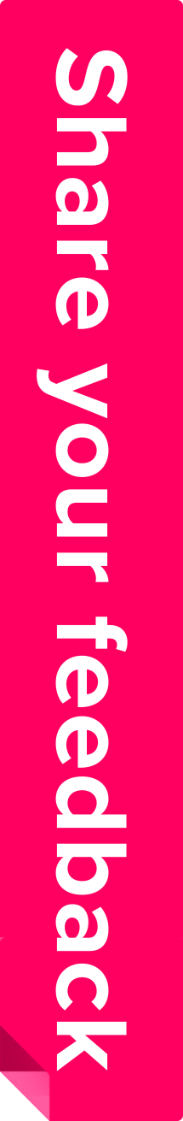

I can understand what you try to say

Your Language is difficult to recognize

Your hand sign is different

Friends Unable to talk to others normal person

Message doesn't conveyed in right way

Other's feel difficulty to talk to them

Communications between Specially Abled person and a normal person has always been a challenging task.

Since normal people are not trained on hand sign language. In emergency times conveying their message is very difficult.

Lack of Education knowledge due to mode of communication.

Job opportunity for specially abled person is lesser compared with normal people.

The project aims to develop a system that converts the sign language into a human hearing voice to convey a message to normal people.

As well as converts speech into understandable sign language for the Specially Challenged people.

Easy to communicate with others.

Specially abled people can feel free to express their views.